Residential Household Hazardous Waste Collection Day

Brewer Public Works
221 Green Point Road

Saturday, October 3, 2020
9 a.m. to 1 p.m.

GREEN POINT ROAD
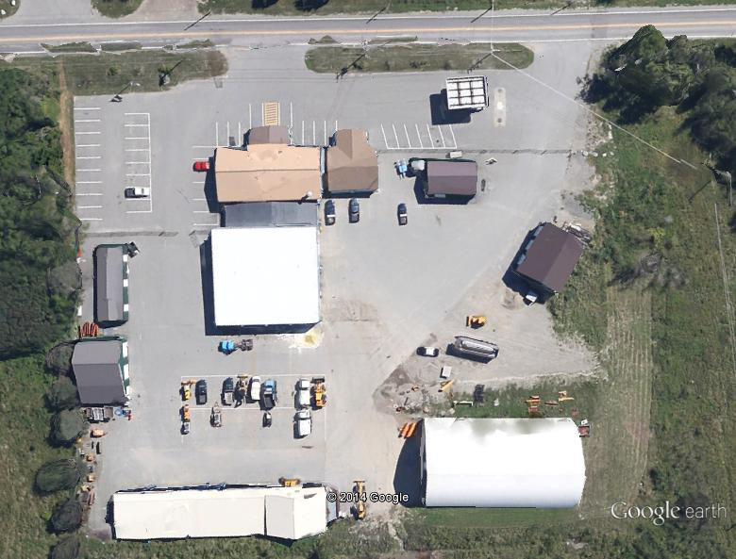

What do I need to pre-register?

Residents from Brewer MUST PRE-REGISTER for the Residential Household Hazardous Waste Collection with ALL pre-registrations being done via telephone or an email. Pre-registration will be through Brewer Public Works Dept during regular business hours (M-F, 7 a.m. to 3 p.m.) at 989-7800 or by email to Public-Works-Dept@brewermaine.gov. Emails MUST have: your name, address, and a detailed list of the types of materials and their quantities. A confirmation email will be sent to all emails. Pre-registration will start SEPTEMBER 8th through THURSDAY, OCTOBER 1st, 2020 by 3:00 p.m.

On collection day, Saturday, October 3rd, you MUST BRING PROOF OF RESIDENCY with you for free disposal at the Brewer Public Works Dept., 221 Green Point Road, Brewer.

What will be included in the Household Hazardous Waste Product collection?

Residents may bring a maximum of 10 gallons of Household Hazardous Waste to the collection.

Linseed Oil Pesticides Aerosol Cans
Turpentine Used Antifreeze Used Motor Oil
Varnish Old Gasoline Transmission Fluid
Chemical Fertilizer Brake Fluid Paint Remover and Thinner
Paint – Oil Based & Latex (see below)*

*NOTICE: IMPORTANT

All latex and oil-based paints will be accepted in any quantity at this event. All containers must have original labels. No drums or containers larger than 5 gallons will be accepted.

Items NOT Accepted:

Alkaline batteries – throw in the trash Biological waste Prescription Medicines/Syringes

Explosives/ammunition Radioactive wastes

What should be done with Universal Waste?

Brewer residents can bring computers, monitors, keyboards, televisions, rechargeable batteries, mercury thermostats, liquid mercury and fluorescent lamps (i.e. Universal Waste) to this event. Residents can also bring Universal Waste to the Universal Waste Collection building at 37 Oak Street on select Saturdays every month for no fee. Call the Water Pollution Control Facility at 989-5417 or go online to the Brewer web site for a 2020 schedule. www.brewermaine.gov

Who can participate in the Household Hazardous Waste Product Collection Program?

Brewer residents only. No businesses.

Is there a charge?
If the resident does not pre-register for a Household Hazardous Collection Permit either via an email or a phone call, a FEE of $6 per gallon will be charged the day of the collection. (Cash or check only)

How do I properly dispose of Household Hazardous Products?

BRING PRODUCTS that say: Caution, Poison, Toxic, Flammable, Pesticide, Warning, Combustible, and/or Danger.

Secondary containers for all products must be clearly marked with contents and be in a securely closed container. Residents should place their containers in cardboard boxes and transport the containers in the trunks of vehicles or in pickup beds to the Brewer Public Works Dept. at 221 Green Point Road. Trained attendants will unload the product containers from your car or truck.
Why can we bring paint this year, when we couldn’t in the past?
The City of Brewer is working with a government agency called Paint Care, who will accept and recycle all paint and primer (latex or oil based) for free.

What are mercury rechargeable batteries?

These batteries are the types of batteries that power rechargeable toys and hand tools. They are also found in some small appliances such as hand-held vacuum cleaners. These batteries also include "Button Cells" that power wristwatches and laser pointers. This type of battery can be brought to the Hazardous Waste Collection day for proper disposal.

What do I do with car, lawnmower, and boat batteries?

These batteries are not part of the Household Hazardous Waste collection and will not be collected. You may consider returning them to the place that they were purchased or call Apex Metals in Holden at (207) 307-7193 or Corey Recycling in Orrington at (207) 825-3595. Apex Metals and Corey Recycling are presently accepting these types of batteries.

What do I do with propane gas tanks?

Propane gas tanks can be turned in to Suburban Propane, 881 Coldbrook Road, Hermon, ME. You should call for hours and fee schedules at 848-2346.
Empty 20 pound propane tanks (those used for outdoor grills) may be taken to the Brewer Landfill when open, and will have a $5.00 disposal fee. Smaller, screw on tanks for table top grills, etc. are $1 each to dispose of at the landfill. Larger tanks have a $20.00 disposal fee.

www.brewermaine.gov

