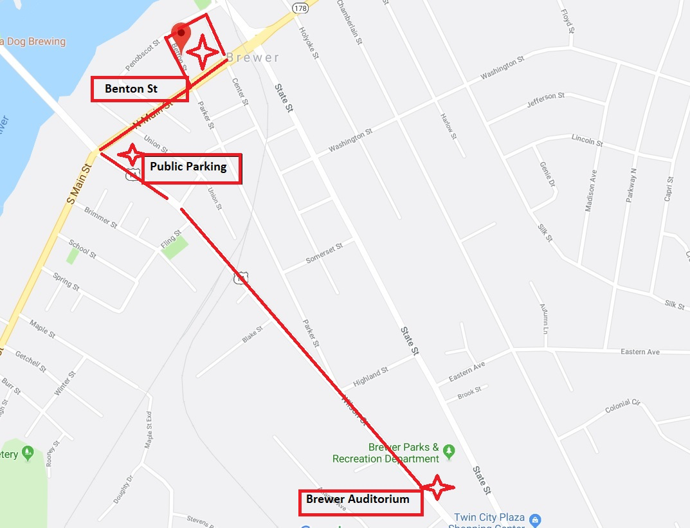
Betton Street

Betton St.

Take a ride on the trolley starting at the Brewer Auditorium down Wilson St, making stops at the Public Parking Lot to Betton St. Trolley loops every 30 minutes from
10:30 am to 4:30 pm.

