City of Brewer, Maine
Progressive. Creative. Forward-thinking. Resourceful.
SafetyWorks!

Program Snapshot
A program where professionals can train you and your employees on a wide range of safety and health topics at no cost to the employer.
This program is an outreach program of the Maine Department of Labor designed to reduce job-related injuries, illnesses and deaths. SafetyWorks! is a voluntary program --- it is not OSHA and cannot issue citations or fines. SafetyWorks! services are available by request and free of charge.

Program Contact Info: SafetyWorks!
Maine Dept. of Labor 45 State House Station Augusta, ME 04333
Phone: 207.623.7900
1.877.723.3345
TTY: 1.800.794.1110
www.safetyworksmaine.com
Email: General.bls-
safetyworks@maine.gov

SafetyWorks! can provide the following services to your business:

- Answer your workplace safety and health questions over the telephone or through Ask the Expert
- Come to your workplace to help you identify hazards and find ways to correct them
- Conduct air or noise monitoring at your workplace
- Provide training on many different safety and health topics
- Lend you videotapes from our video lending library
- Send you publications
- Provide injury and illness statistics
- Help you improve your safety and health program
- Help you understand OSHA regulations

Here in Brewer, our approach to Economic Development is anything but business as usual.
We treat each Brewer business like it’s our own business, and we’re passionate about making sure you succeed. Whether you’re an aspiring entrepreneur just starting out, a mature company continuing its legacy, or anything in between, come and see why Brewer means Business. Your business.

CONTACT
D’arcy Main-Boyington
Economic Development Director
dmain-boyington@brewermaine.gov
Renee Doble
Economic Development Specialist
rdoble@brewermaine.gov

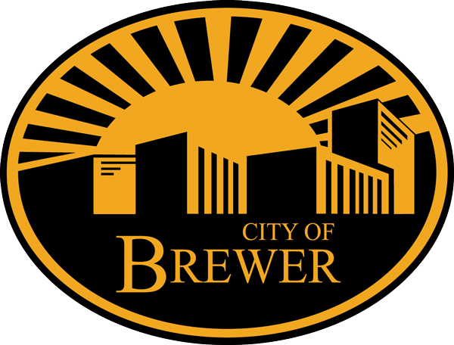

CITY OF BREWER
80 North Main Street FAX
Brewer, ME 04412 207.989.8049
PHONE WEB
207.989.7500 www.brewermaine.gov

