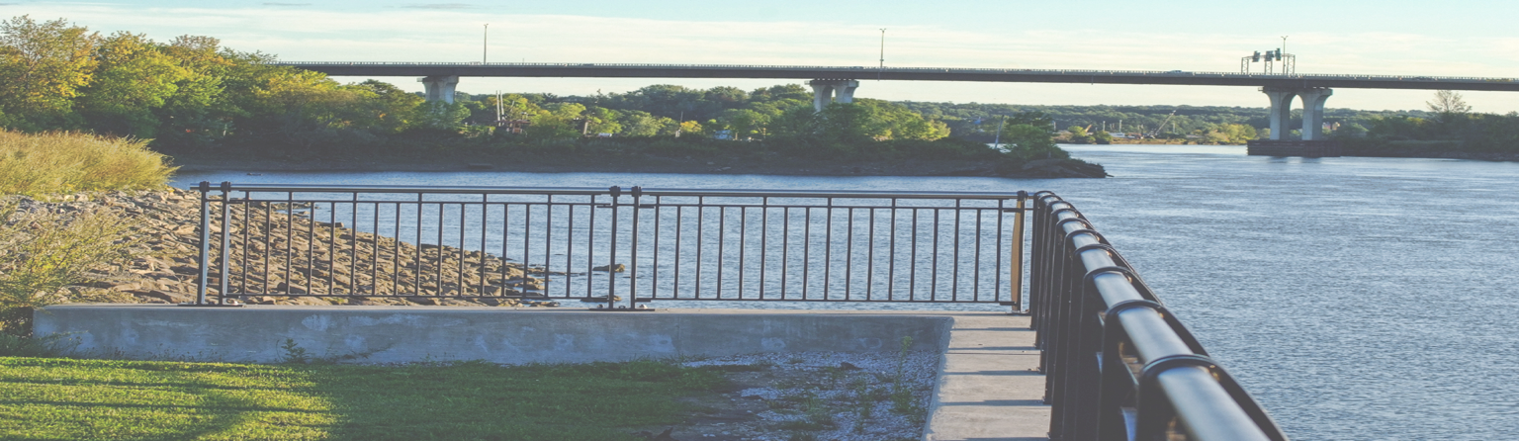

City of Brewer, Maine
Progressive. Creative. Forward-thinking. Resourceful.
CDBG Development Loan Fund
Program Snapshot
The Economic Development Program provides gap funding in the form of grants and loans for communities to assist businesses in the creation of quality jobs for low and moderate- income persons.
This Development Fund Loan (DF), as part of the Community Development Block Grant (CDBG) program, is used for acquisition of existing facilities, land and site improvements necessary for the construction of a new facility, rehabilitation or construction of commercial or industrial buildings, structures, non-capital equipment, capital equipment, working capital and real property improvements. The program is administered by the Maine Department of Economic and Community Development.

Program Contact Info: Maine DECD
Office of Community Development
111 Sewall St, 3rd Floor 59 State House Station Augusta, ME 04333-0059

Phone: 207.624.7484
Fax: 207.287.8070
TTY: 1.800.437.1220

www.meocd.org
- The maximum loan award is $300,000
- The business must be creating jobs, and the amount of the loan is proportional to the number of jobs created.
- Development Fund (DF) monies are granted to the community and then loaned by the community to the business.
- All DF repayments by assisted business are made to DECD.
- DF program funds cannot be used to refinance existing debt.

Here in Brewer, our approach to Economic Development is anything but business as usual.
We treat each Brewer business like it’s our own business, and we’re passionate about making sure you succeed. Whether you’re an aspiring entrepreneur just starting out, a mature company continuing its legacy, or anything in between, come and see why Brewer means Business. Your business.
BREWER
CITY OF

CONTACT
D’arcy Main-Boyington, Economic Development Director Dmain-boyington@brewermaine.gov
Renee Doble

Economic Development Specialist
rdoble@brewermaine.gov

CITY OF BREWER

80 North Main Street Brewer, ME 04412 PHONE
207.989.7500

FAX 207.989.8049 WEB

www.brewermaine.gov

