City of Brewer
Residential Curbside Waste Collection Program Changes

Goodbye orange bags.
Hello orange tags.

The City of Brewer is excited to announce changes to its residential curbside waste program that take full advantage of the efficiencies and technological capabilities offered by the Coastal Resources of Maine advanced waste processing and recycling facility now open right across the river in Hampden. The changes will streamline and simplify the process for residents to dispose of materials curbside and save the City $100,000 in current program costs.
The changes are driven by the fact that Coastal facility’s unique technology redefines “waste” as a “resource”, recovering and upgrading many of the wasted materials thrown out each week. Waste will be sorted at the Coastal facility where separate parts will be transformed into something useful. Coastal’s machinery pulls out items such as cardboard, metals, and high-quality plastics for sale. Food waste is separated from fibers and unrecyclable material; even “hard to recycle” items like disposable coffee cups and tetra pak are processed. In the past, recyclables that were soiled with food were not able to be recycled—but the Coastal facility is able to make use of this discarded material.
With Coastal’s capabilities, now up to 80% of all materials collected curbside will get recycled or put to other productive use, so there is no need to separate out a limited set of materials and have them collected by a separate recycling truck. This all-in-one approach, sometimes referred to as commingled collection, simplifies the disposal process for residents who no longer will need to think about whether or not something is “recyclable”. Now, it virtually all is, and Coastal will do the separating for us.
The City understands that the recycling program was an important part of its Pay As You Throw system as it allowed residents to minimize their waste disposal costs. In recognition of this, the City is making two important enhancements to its Pay As You Throw program.
First, on September 1, the City is changing from a bag-based Pay As You Throw program to a tag-based system. For the same $2.00 that now gets one a 33-gallon orange bag, a resident will obtain a Pay As You Throw sticker that will be affixed to any size and quality bag they wish, such as a 60 gallon heavy duty contractor bag, as long as the contents weigh less than 40 pounds. In addition to providing residents significantly more volume for the same cost, this program change resolves the complaints many residents have about the inconsistent quality of the orange bags.
The second Pay As You Throw program enhancement is that cardboard will not need to be bagged. Residents may place neatly stacked cardboard alongside their properly tagged trash, and it will be collected weekly, free of charge.
Brewer implemented Pay As You Throw in 2011 to help offset some of the cost of the curbside collection and disposal service it provides to residents. The program has successfully reduced the amount of waste disposed by 50%. The changes coming in September will continue these benefits while offering program improvements to residents.
Orange Tag Program Highlights
- Replaces separate trash and recycling collection with a comprehensive all in one curbside resource recovery system
- Changes from bag-based Pay As You Throw program to tag-based program
- Same $2 cost per tag, but the tag can go on any size bag (as long as contents weigh less than 40 lbs)
- Cardboard is free if neatly bundled and placed alongside tagged bags

COMING SEPTEMBER 1!
From Orange Bags to Orange Tags
Frequently Asked Questions

When do I start using the tags?
September 1, 2019
Where will the tags be sold and how much will they cost?
We expect most stores that currently sell Brewer orange bags will choose to sell the tags. Tags will also be for sale at Brewer City Hall and the Library. Tags are $2.00 each.
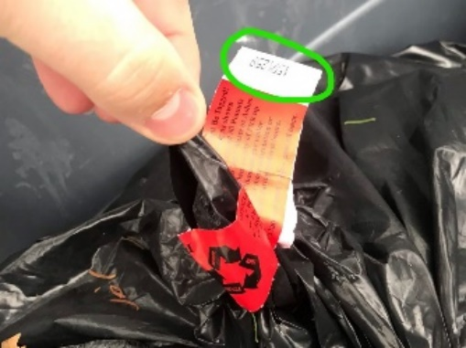
What color will the tags be?
Orange.
How do I put a tag on a bag?
The tags are about 7” long by 1.5” high and are stickers.
You will remove the backing and wrap the sticker around the neck of the
garbage bag and stick the two ends to each other like this:
If they are really stickers, why do people call them tags?
Good question! Probably because its easier to say “tag” than “sticker”.
What do I do with my recycling?
Because the new Coastal facility recycles and converts up to 80% of the all of the material it receives, there is no need to separate out “recyclables” from trash. All items you want to dispose of will go in bags.
How will I fit my bulky cardboard in a bag without it tearing?
Cardboard, if neatly stacked and bundled, can be placed alongside properly tagged trash bags, and it will be picked up weekly, free of charge.
Won’t this change cost me more since what I recycle currently will now need to go in bags?
We do not think so; in fact, we expect many residents will see a savings since a $2 tag will be able to get you 50% to 100% or more volume than under the current program and cardboard will be collected free, if neatly stacked.
What kind of bag do I need to use?
The size, type, and quality of bag is up to you. The only restriction is that the contents must weigh less than 40 pounds.
I can’t manage a 40-pound, or even a 20-pound, bag. Do they need to be that heavy?
No. 40 pounds is the maximum weight we will accept. You can put as much—or as little—waste in a bag as you wish, as long as it weighs less than 40 pounds.
Can I put a tag on a trash barrel or container?
No.
Can I put my bags in a trash barrel or container to keep the crows from getting to them?
Yes. But every bag in the container must have its own Brewer tag affixed to it.
What do I do with my trash and recycling between now and September 1?
Residents must continue to use official Brewer orange bags for their trash through the end of August. The City’s contractor, Pine Tree, will continue to collect recycling every other week through August.
What if I still have orange bags on September 1?
No worries. Pine Tree will continue to pick up orange bags. Official Brewer orange bags do not need a Brewer tag.
Will the City be sending out more information about this change?
Yes. The City will be mailing information to all residents in the month of August.

